**GAME DESIGN DOCUMENT**

**THE** Grand Theft Auto clone

Grab That Auto

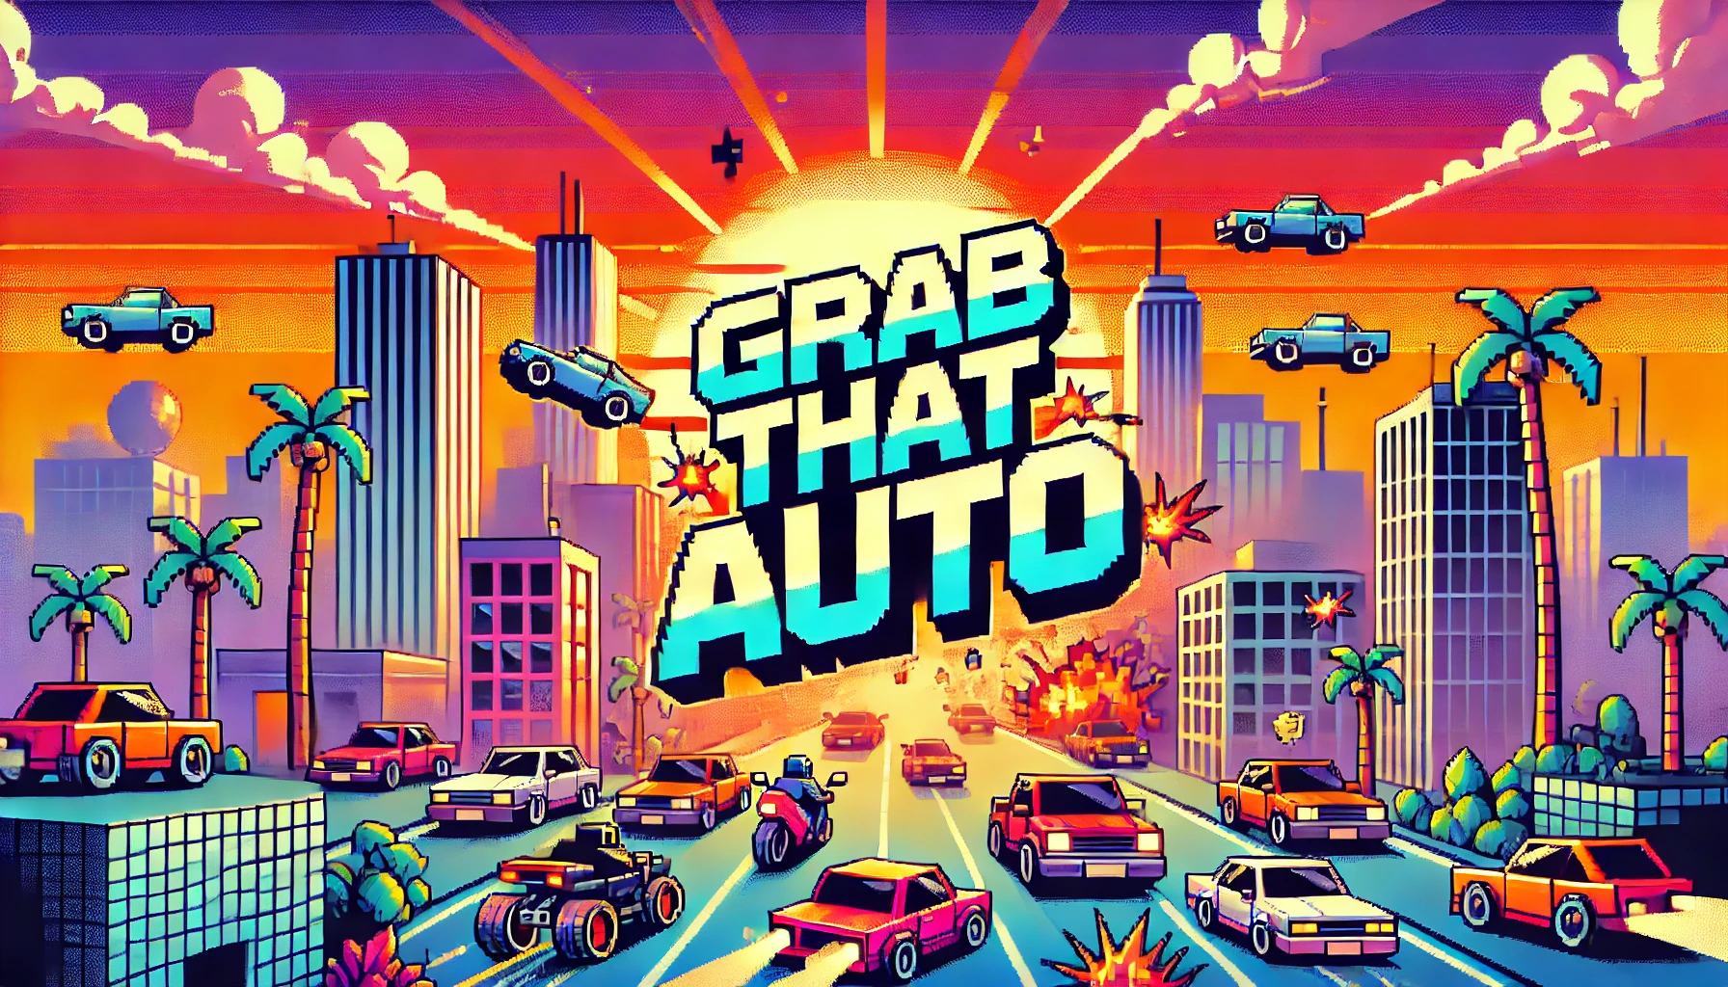

**Last Updated:**

24/11/2024

**Prepared By:**

Jamil Maarrawi

Maksym Lystopad

Mateusz Kaminski

**TABLE OF CONTENTS**

Game Analysis 3

Glossary 4

Use Case Diagram 7

Use Case Descriptions 8

Genre(s) 21

Platforms 21

Target Audience 21

Storyline & Characters 22

Gameplay 25

Overview of Gameplay 25

Gameplay Guidelines 26

Game Objectives & Rewards 27

Gameplay Mechanics 28

Level Design 30

Control Scheme (Default) 31

Game Aesthetics & User Interface 32

# Game Analysis

This GTA 1-inspired game offers an action-packed experience placed in a diverse environment that combines arcade-style action with a minimalist yet engaging gameplay loop. Players step into the shoes of a mischievous anti-hero navigating a bustling cityscape, completing missions, and wreaking havoc in a pixelated urban playground. This game delivers a simplified take, focusing on streamlined mechanics and a smaller scope, making it accessible to newcomers and a nostalgic treat for fans of retro gaming.

The fun lies in its raw and unapologetic approach to action, allowing players to steal cars, explore a fascinating game region, and complete simple missions. Whether you’re a law-abiding citizen or unleashing chaos with a stolen vehicle, this game promises pure, unfiltered arcade fun.

# Glossary

**A**

* **Attack Key**: The button or key designated to initiate melee or firearm attacks (default: **SPACE**).
* **Axial Movement**: A two-dimensional movement system allowing a character to navigate horizontally and vertically (e.g., **W, A, S, D** keys).

**B**

* **Boosters**: Items purchased from shops that provide temporary enhancements (e.g., faster movement). Boosters are applied immediately after purchase and cannot be stored.

**C**

* **Crime Level**: A representation of the game's difficulty, influenced by the player's criminal activities. Higher crime levels result in more intense police response. Crime Levels range from 0 (no wanted level) to 5 and are represented by stars in the HUD
* **Critical Hit**: A future enhancement where attacks deal additional damage based on certain conditions.
* **Confirmation Key**: The key used to confirm actions, such as purchasing items in a shop (default: **ENTER**).

**D**

* **Destructible Object**: An object in the game world that can be damaged or destroyed (e.g., crates, vehicles) through player actions.

**E**

* **Experience (XP)**: A progression metric earned through missions and gameplay actions. XP unlocks new weapons, items, and shop features.

**F**

* **Failure State**: A condition triggered when the player fails a mission or objective due to reasons such as running out of time, dying, or losing a critical item.

**H**

* **Heist Bucks (HB)**: The in-game currency used to purchase items, weapons, and boosters. Earned by completing missions and achieving in-game objectives.

**I**

* **Inventory**: A system that allows the player to store and manage weapons. Boosters and other items are not stored but used immediately upon purchase.
* **Interaction Key**: The key used to engage with the game world, such as entering vehicles, picking up items, or initiating missions (default: **E**).

**L**

* **Line of Sight**: A mechanic used exclusively by the Paramedic NPC. After performing a revival attempt (successful or not), the Paramedic NPC drives away until they are no longer visible to the player. Once out of the player's line of sight, the Paramedic NPC despawns.

**M**

* **Mission Trigger**: A marker or object in the game world that the player interacts with to begin a mission.
* **Map Overlay**: The visual representation of the game world, overlayed on the gameplay screen. Toggling on the map overlay does not pause the game.
* **Melee Attack**: Close-range combat initiated by the player, typically with fists or melee weapons.

**N**

* **NPC (Non-Playable Character)**: A character controlled by the game’s AI. Examples include Police NPCs, Gang Bosses, and Civilians.

**P**

* **Paramedic NPC**: A specialized NPC that revives downed NPCs in the game world. They appear in response to violent actions.
* **Player Character**: The protagonist (Jack Quicksteal) controlled by the player, capable of moving, attacking, driving vehicles, and completing missions.
* **Police NPC**: An AI-controlled character representing law enforcement. They patrol the game world, detect crimes, and pursue the player if crimes are committed.
* **Projectile**: A ranged attack from a firearm, governed by range, and ammunition count.

**R**

* **Realive NPC**: A use case describing the mechanic where Paramedic NPCs revive downed NPCs. The revived NPC resumes normal behavior with partial health.

**S**

* **Sandbox Mode**: The default game mode, focusing on open-ended exploration, completing missions, and causing chaos with no fixed endpoint.
* **Shop Interface**: A pop-up menu triggered by interacting with a shop marker, allowing the player to buy weapons, items, or boosters.
* **Success State**: The condition where a mission is completed by fulfilling all objectives, earning rewards such as Heist Bucks and XP.
* **Switch Weapon Key**: The key used to cycle through the player’s inventory of weapons (default: **TAB**).

**T**

* **Trial Mode**: A secondary game mode with higher difficulty, where players face aggressive AI and limited lives.
* **Trigger Conditions**: Predefined events that activate NPC behavior or game mechanics (e.g., crimes triggering police pursuit).

# Use Case Diagram

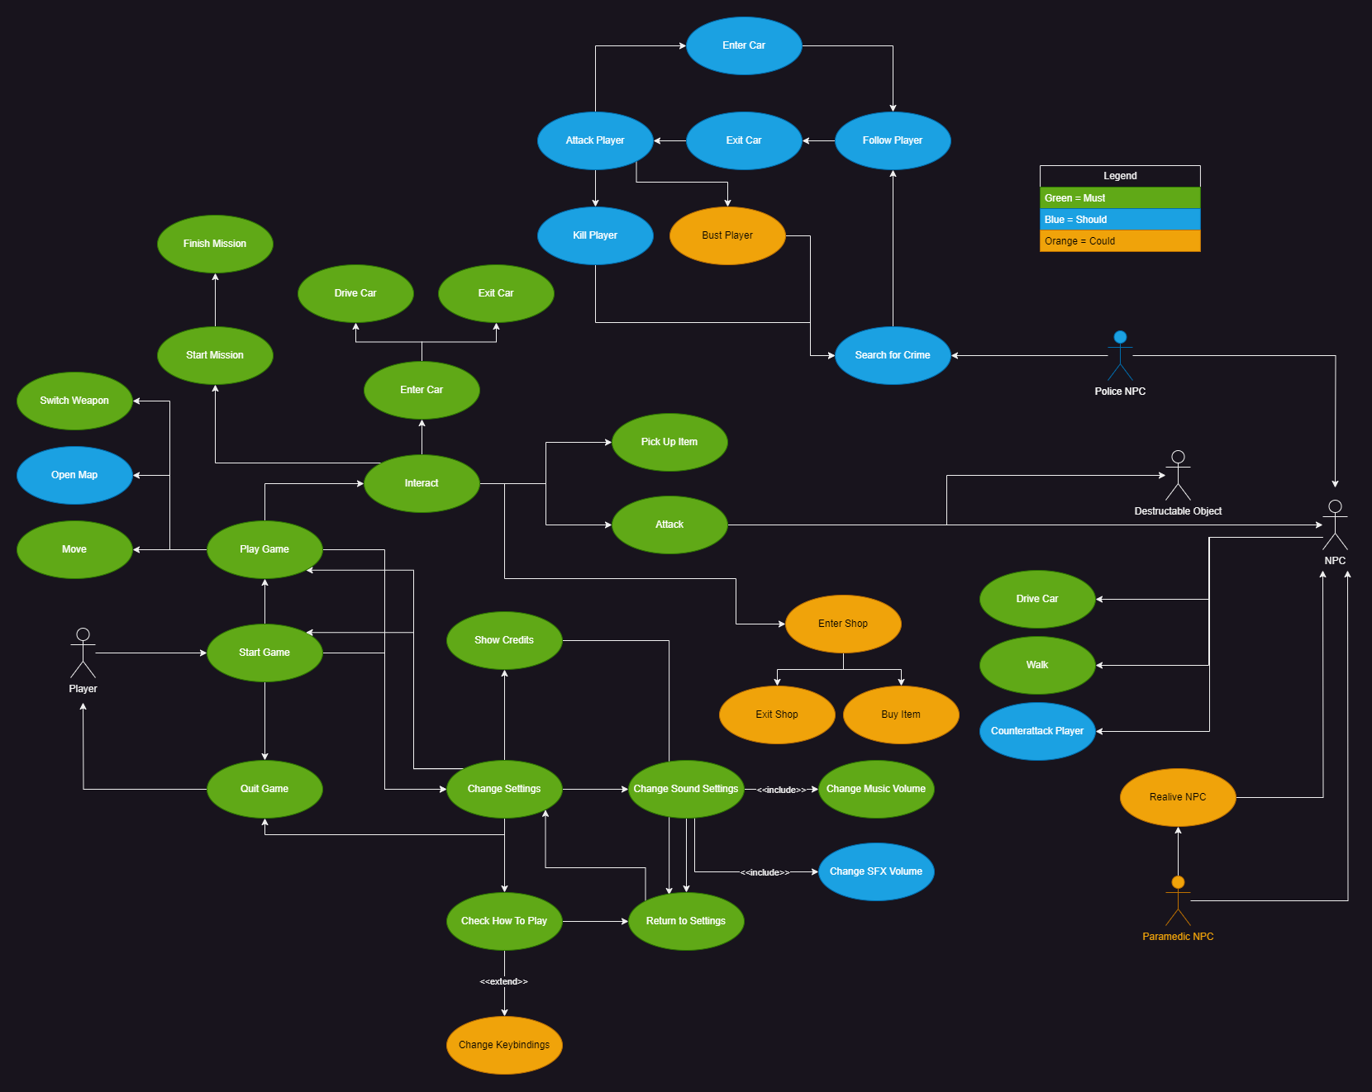

# Use Case Descriptions

|  |  |
| --- | --- |
| Use Case | **Start Game** |
| Actor | Player |
| Description | The player launches the game by running the executable file, which initializes the game system and displays the main menu. |
| Stimulus | The player clicks on the executable file (.exe) |
| Response | The game system loads all necessary resources and transitions to the main menu interface. |
| Criteria | * The executable file must:   + Have a recognizable icon and the filename "GrabThatAuto.exe" to ensure easy identification by the player. * A splash screen or loading indicator could be displayed while the game initializes. * The system must transition to the main menu after initialization, presenting the following options:   + Start Game   + Settings   + Quit Game * The system should handle potential errors (e.g., missing files or incompatible hardware) gracefully by displaying appropriate error messages. |
| Comments | This use case represents the entry point to the game, bridging the player’s environment (desktop or launcher) to the game’s main interface. |

|  |  |
| --- | --- |
| Use Case | **Move** |
| Actor | Player |
| Description | The player can control their character's movement in the game world by using directional keys. Movement allows the player to explore the environment, interact with objects, and progress through the game. |
| Stimulus | The player presses one of the movement keys (per default: W, A, S, or D). |
| Response | The game system moves the player character in the corresponding direction and updates the game world accordingly. |
| Criteria | * The movement controls must be mapped as follows per default:   + W: Move Up   + A: Move Left   + S: Move Down   + D: Move Right * The game must display the character's movement in real-time. * The system should account for collisions:   + Prevent the player from moving through walls, obstacles, or other characters.   + Trigger events if the player collides with interactive objects or enters designated zones. * The game will not include sprinting, jumping, or dodging as separate movement mechanics. |
| Comments | This use case is foundational for gameplay, as it underpins the player's ability to explore and interact with the game world. |

|  |  |
| --- | --- |
| Use Case | **Switch Weapon** |
| Actor | Player |
| Description | The player can switch between available weapons in their inventory to adapt to different situations during gameplay. |
| Stimulus | The player presses the designated key (per default: TAB) to cycle through the weapons in their inventory. |
| Response | The game system updates the currently equipped weapon, displaying it visually and making it available for use. |
| Criteria | * Switching to the next weapon in the inventory must be mapped to the TAB key per default. * Switching to the previous weapon in the inventory could be mapped to the TAB + Shift key per default. * The game must:   + Display the currently equipped weapon on-screen or in a dedicated HUD element.   + Handle switching seamlessly, without pausing the gameplay.   + Prevent switching to a weapon if the inventory is empty. * Switching should include visual and auditory feedback. |
| Comments |  |

|  |  |
| --- | --- |
| Use Case | **Start and Finish Mission** |
| Actor | Player |
| Description | The player begins a mission by interacting with a mission trigger in the game world. The mission can be completed successfully by fulfilling its objectives or end in failure due to specific conditions such as the player dying, failing an objective, or running out of time. |
| Stimulus | **Start:** The player approaches a mission marker and interacts using the interaction key (per default: E).  **Finish:** The mission ends when all objectives are completed, or a failure condition is triggered. |
| Response | **Start:** The game system initializes the mission, displays the objectives, and begins tracking the player's progress.  **Finish (Success):** The game evaluates completed objectives, rewards the player, and transitions to post-mission gameplay.  **Finish (Failure):** The game notifies the player of failure, resets the mission state, and provides options to retry or return to free exploration. |
| Criteria | * Starting a Mission:   + Mission triggers (e.g., markers, zones, or NPCs) must be clearly visible and accessible.   + The interaction key must initiate mission interaction and start tracking objectives.   + Mission objectives must be displayed clearly on the HUD once the mission begins.   + The game should confirm mission start through a visual or auditory cue (e.g., sound effect or mission title display). * Finishing a Mission: * Success:   + - All objectives must be achieved (e.g., reaching a location, defeating enemies, delivering an item).     - The game must provide rewards (XP and Money) and confirm success with a message. * Failure:   + - Triggers must include:       * The player's character dying.       * Running out of time (if a timer applies).       * Failing critical mission objectives (e.g., losing an item, target escaping).     - The game must display a failure notification and clear the objectives from the screen.     - The player must be given options such as:       * Retrying the mission.       * Returning to free exploration. * Missions will not branch into alternate paths based on failure conditions. * The system will not provide mid-mission checkpoints; missions must be completed or failed in one attempt. |
| Comments |  |

|  |  |
| --- | --- |
| Use Case | **Enter and Drive Car** |
| Actor | Player |
| Description | The player interacts with a car to enter it and take control, enabling them to drive the vehicle within the game world. This action allows for faster travel. Vehicles can also be stolen from NPC’s. |
| Stimulus | **Enter Car**: The player approaches a car and presses the interaction key to enter.  **Drive Car**: The player uses movement keys to control the vehicle after entering. |
| Response | **Entering**: The game transitions control from the player character to the car. The character disappears, and a sound or animation should indicate the action.  **Driving**: The car responds to directional inputs, allowing movement and interaction with the environment. |
| Criteria | * Cars must be interactable objects when the player is within a designated range. * Pressing the interaction key must transition control to the car and removes the character from view. * Feedback, such as an animation or sound effect, should confirm entry. * The vehicle controls must map to the keyboard. By default:   + W: Accelerate forward.   + A: Steer left.   + S: Reverse or brake.   + D: Steer right. * The game must simulate basic driving physics, including acceleration, deceleration, and collisions with obstacles. * Sound effects and visual HUD updates should accompany driving (e.g., engine noise, speed indication). * Exiting the car must be possible by pressing the interaction key again, transitioning control back to the player character. * There will be no detailed interior views or manual controls like gear shifting. |
| Comments | Future enhancements could include vehicle-specific features (e.g., boosting, nitro, or upgrading handling). |

|  |  |
| --- | --- |
| Use Case | **Attack** |
| Actor | Player, NPC, Destructible Objects |
| Description | The player can attack NPCs and destructible objects using melee actions or firearms. This allows the player to eliminate NPC instances and damage or destroy interactable objects in the environment. |
| Stimulus | The player initiates an attack (melee or weapon depending on selection) by pressing the attack key (per default: SPACE). |
| Response | **For NPCs:**   * The game reduces the NPC's health based on the attack type (melee or firearm). * If health reaches zero, the NPC is eliminated.   **For destructible objects:**   * The game reduces the object's durability or health. * When health reaches zero, the object breaks. |
| Criteria | • **Attack Controls**:   * Melee attacks must be triggered by pressing the attack key when no firearm is equipped. * Firearm attacks must be triggered by pressing the attack key when a firearm is equipped.   • **Target Interactions**:   * NPCs must respond dynamically to attacks:   + Reduce health when hit.   + Play appropriate visuals based on damage received. * NPCs should counterattack if the attack type corresponds to their equipment (e.g., if the NPC has no weapons it should respond to melee attacks only). * NPCs should run away if the attack type is stronger than their equipment * Destructible objects must have defined durability and react to attacks:   + Visually display damage.   + Break when health reaches zero.   • **Combat Mechanics**:   * Weapons (melee or firearms) must have damage values that affect targets differently. * Firearms must track ammunition, reducing available bullets with each shot. * Projectile range must be calculated for firearms, factoring in player position and target distance.   • **Death or Destruction**:   * NPCs must be displayed as corpses when their health reaches zero. * NPCs must be removed from the game world 2 Minutes after dying. * Destructible objects must transition to a "destroyed" state upon reaching zero durability.   Destructible objects will not include advanced physics-based destruction (e.g., dynamic shattering).  The player cannot repair damaged destructible items or revive defeated NPCs. |
| Comments | Future enhancements could include critical hits, weapon upgrades, or advanced AI responses for NPCs. |

|  |  |
| --- | --- |
| Use Case | **Change Settings** |
| Actor | Player |
| Description | The player navigates to the settings menu to adjust game parameters such as audio or control configurations. Changes made are saved and applied immediately upon exiting the menu. |
| Stimulus | The player selects the Settings option from the main menu or in-game menu. |
| Response | The settings menu is displayed, allowing the player to make adjustments. The game applies and saves changes based on player input |
| Criteria | * The settings menu must be accessible from both:   + The main menu.   + The in-game pause menu. * The player must be able to navigate to the settings menu using mouse movement and clicks. * The settings menu must allow music volume regulation * The settings menu should allow SFX volume regulation * The settings menu could allow changing all keybindings for character and vehicle control * Changes should be previewed in real-time where applicable (e.g., click sounds at volume change) * Changes must be saved upon clicking the “save” button. * Restoring default values must be available as an option. |
| Comments |  |

|  |  |
| --- | --- |
| Use Case | **Open Map** |
| Actor | Player |
| Description | The player can open a map to view their current location, mission objectives, or points of interest within the game world. This functionality aids in navigation and mission planning. |
| Stimulus | The player presses the designated map key (per default: M) during gameplay. |
| Response | The game displays the map overlay, showing relevant details about the player's position and objectives. |
| Criteria | * The map should be accessed during gameplay only. * Pressing the map key should toggle the map overlay on or off * The map should show the players current location, marked clearly * The map should show current mission objective or markers for ongoing missions. * The map could show points of interest, such as shops. * The map should contain a legend which explains the different markers. * The map will not pause gameplay while displayed. * The player will not be able to navigate the map (zoom in/out, panning) * The map will not include navigation (path finding) between two points in any way. |
| Comments | This use case is a should goal, enhancing navigation but not critical to gameplay. |

|  |  |
| --- | --- |
| Use Case | **Police NPC** |
| Actor | Police NPC, Player |
| Description | The Police NPC patrols the game world to detect player-initiated crimes and respond by pursuing the player or attempting to capture them. The NPC's actions depend on proximity and the severity of the player's actions. |
| Stimulus | The Police NPC detects a crime committed by the player (e.g., attacking an NPC, stealing a car, or damaging property). |
| Response | The Police NPC reacts dynamically:   * Begins pursuit of the player. * Attempts to capture or neutralize the player. |
| Criteria | * Patrolling Behavior:   + The Police NPC should drive around random locations when not pursuing the player.   + The NPC actively scans the environment for crimes within a specific detection radius. * Crime Detection:   + Crimes that should trigger the Police NPC include:     - Attacking an NPC.     - Damaging or destroying property.     - Stealing a vehicle.   + The detection radius will not account for obstacles (e.g., walls blocking the line of sight). * Pursuit Mechanics:   + Once a crime is detected:     - Multiple NPC instances appear in a predefined radius around the player. They should not appear in line of sight of the player.     - The NPCs should pursue the player until the player dies or gets busted.     - The NPC follows the player on foot or enters a vehicle if the player is driving.   + The amount of spawned police NPC instances should depend on the crime level (1-5)   + The current crime level should be displayed in the HUD * Capture Attempt:   + When close enough to the player, the NPC should attempt to:     - Arrest the player if on foot and the current crime level is 1 or 2.     - Ram the player’s vehicle if the player is driving.   + A successful capture ends the player’s current mission and triggers a failure state (e.g., "Player Busted"). * Police NPCs will not coordinate. They operate as a single unit |
| Comments | This use case is a should goal, enhancing difficulty but not critical to gameplay. |

|  |  |
| --- | --- |
| Use Case | **Realive NPC** |
| Actor | Paramedic NPC, NPC |
| Description | When an NPC instance is killed, a Paramedic NPC can arrive at the scene to revive the downed NPC, bringing them back to an active state in the game world. This feature is a dynamic, optional interaction that adds realism and interactivity to the game environment. |
| Stimulus | A nearby NPC instance is killed, triggering the Paramedic NPC to appear and attempt a revival. |
| Response | The Paramedic NPC arrives at the location of the downed NPC, performs a revival action, and restores the NPC to an active state with limited health. |
| Criteria | * Trigger Conditions:   + The downed NPC could be in a predefined radius of the player   + The Paramedic NPC could appear at the location after a predefined timer runs out. * Paramedic NPC Behavior:   + The paramedic NPC could spawn near the downed NPC   + The paramedic NPC could move to the downed NPC and perform the revival.   + After revival the paramedic NPC could enter his car and drive out of sight of the player. * Revived NPC State:   + The NPC is restored to an active state with partial health   + The revived NPC resumes their usual behavior * If the paramedic NPC gets interrupted (e.g., attacked by the player), the revival fails, and the rescued NPC remains down. * Players will not be able to request the revival of specific NPCs * The paramedic NPC will not revive mission relevant NPCs |
| Comments | This use case is a could goal, further enhancing the gameplay realism but not critical to the whole system at all. |

|  |  |
| --- | --- |
| Use Case | **Shop** |
| Actor | Player |
| Description | The player interacts with a predefined shop location on the map to open a shop interface. Shops are not physically enterable; instead, a popup window allows the player to buy items, weapons, or boosters based on their XP level and currency. Purchased weapons are stored in the inventory, while other items are used immediately after purchase. |
| Stimulus | The player approaches a shop marker on the map and interacts with it using the interaction key. |
| Response | A shop interface opens, displaying items and weapons available for purchase based on the player’s XP level and current funds. |
| Criteria | * The player could interact with a predefined position on the map (shop marker) using the interaction key which opens the shop interface * The shop interface could visually display the shop type (Weapons, Item Shop, Pharmacy) * Each shop could offer a range of goods some of which could be unlocked by reaching higher Experience (XP) levels. * The shop interface could display the following:   + The players current XP level   + The players current funds   + The price and XP requirements for each item * The player could be able to buy available items by navigating the list with the movement keys (per default: W, A, S, D) and confirming by clicking the confirm button (per default: ENTER) * The players funds could be decreased by the item price upon confirmation * Any boosters could be applied to the player immediately after purchase. Weapons and ammunition could be added to the player’s inventory. * The player could leave the shop by selecting the “Leave Shop” option in the shop interface * Players will not be able to sell items or weapons back to the shop. |
| Comments | This use case integrates multiple shop types, balancing player progression with XP and currency requirements. |

# Genre(s)

Top-Down Action, Semi Open-World Adventure, Driving Simulator

# Platforms

Windows 10 and higher

# Target Audience

Retro Gaming Enthusiasts:

* Players who actively seek retro-style games or modern adaptations of older classics. Grab That Auto’s pixel-art style and top-down perspective resonate with this group.

Open-World Fans:

* Fans of sandbox games who love freedom, exploration, and emergent chaos.

Indie Game Supporters:

* Gamers who appreciate creative, low-budget titles and are active in communities like Steam, Reddit, and Discord.

# Storyline & Characters

In the chaotic streets of Snatchburg, Jack Quicksteal, a silent and enigmatic figure with a smirk, navigates a world teetering between crime and order. The city's underbelly is controlled by ruthless gang bosses, each vying for dominance while clashing with relentless police officers sworn to uphold the law. Amidst the turmoil, civilians try to survive, often fleeing from the violence that erupts around them. Medics rush to the aftermath of every conflict, offering aid indiscriminately, while Jack maneuvers through this fractured world, exploiting its chaos for their own enigmatic purposes.

In this unpredictable city, every action has consequences, every encounter a gamble, and Jack's journey is shaped by the alliances they form and the havoc they leave in their wake.

|  |  |  |  |
| --- | --- | --- | --- |
| Character | Description | Characteristics | Misc. Info |
| Protagonist  (Jack Quicksteal)  Ein Bild, das Pixel, Screenshot, Spielesoftware, 3D-Modellierung enthält.  Automatisch generierte Beschreibung | Playable character. Protagonist is a prototype of player. They are silent and with a distinct smirk on their face. It is hard to imagine that this character is enjoying the chaos, though its similarly hard to imagine any sign of remorse on their face | Main playable character is able to move in the game world freely, as well as utilize in-game vehicles to their advantage. They are able to initiate combat with other entities in the game, utilizing any in-game gear available to them | Character should not visibly present any kind of emotions about the actions that the Player does |
| Ein Bild, das Pixel, Cartoon enthält.  Automatisch generierte BeschreibungGang boss | NPC, non-playable  This character represents a highly ranked member of a crime gang. This is a type of NPC that the player could meet in the game world. They spawn in special locations and their behavior is based on context. It could be possible for the player to influence this character’s attitude towards the player | This character is controlled by AI. Under some circumstances they can attack or aid the player. They are hostile to Police officers or any version of law enforcements and will attack such characters on sight, although not actively look for them.  This character can make use of some weapons in game. | Generic type of character. For each possible gang such type of character would be personalized to better fit said gang aesthetic |
| Ein Bild, das Kleidung, Gesetzesvollstreckung, Staatliche Behörde, Sicherheit enthält.  Automatisch generierte BeschreibungPolice Officer | NPC, non-playable  This character represents a member of law enforcement. This is a type of NPC that the player could meet in the game world. They spawn in most of the in-game area and wonder the world looking for crime actions. When they spot crime, they try to terminate the origin of said crime action. These origins include actions of the player; thus, law enforcement will hunt the player if they commit a crime | This character is controlled by AI. Under some circumstances they can attack or aid the player. They are hostile to Gang members or any version of unlawful actions and will attack such characters on sight. They will actively seek those who commit unlawful actions  This character will make use of a limited number of weapons. | Generic type of character. There are different ranks of this type of unit, higher ranks poses more lethal weapons and should be considered as more dangerous enemies |
| Ein Bild, das Pixel, Screenshot, 3D-Modellierung, Spielesoftware enthält.  Automatisch generierte BeschreibungEin Bild, das Pixel, Screenshot, 3D-Modellierung, Spielesoftware enthält.  Automatisch generierte BeschreibungEin Bild, das Pixel, Screenshot, 3D-Modellierung, Spielesoftware enthält.  Automatisch generierte BeschreibungCivilians | NPC, non-playable  These characters represent a generic type of civilian pedestrians, who are found all around the in-game world. They are diverse and do not poses any specific characteristics. | Civilians are AI controlled and will wander around the virtual word without a real goal. When confronted with unlawful actions of violence, these characters will most likely flee locations where said actions appear. | Civilians could have more unique reaction patters to unlawful actions and violence depending on the type of action. |
| Ein Bild, das Pixel, Cartoon enthält.  Automatisch generierte BeschreibungMedic | NPC, non-playable  This is a type of NPC that the player could meet in the game world after violent actions have been committed. They spawn in most of the in-game area and navigate directly to aid those who have been hurt in violence. | This character is controlled by AI. They will aid any type of character, regardless of their origin, or whether they are the origin of violence. | Medics reaction time could be dependent on in-game region in which violence occurs |

# Gameplay

## Overview of Gameplay

Grab That Auto is a top-down semi-open-world action-adventure game heavily inspired by the classic GTA 1 formula, blending elements of retro arcade gameplay with modern storytelling and mechanics. It stands out by incorporating rogue-like elements (randomized gear elements and events), adding layers of replayability, and a dynamic world that evolves based on the player’s actions. It can be classified as a hybrid of semi-open-world action, retro arcade games, and rogue-likes.

Grab That Auto is a pure single player experience and has a default “Sandbox” game mode that lets you complete missions and earn game score points. If our resources suffice, we might add another game mode “Trial” that is based on fragile difficulty balancing and offers only one game life. By incorporating suitable sound effects and musical ambience, as well as proper visual effects, this game aims at creating a unique experience for the player. What's more, the game aims to create a basic urban simulation that would feel unique on every replay.

## Gameplay Guidelines

1. **Violence and Gore**

* **Allowed:**
  + Stylized, pixel-art depictions of violence (e.g., explosions, gunfights, and hand-to-hand combat).
  + Blood effects in a retro, non-realistic style.
* **Not Allowed:**
  + Graphic depictions of gore, such as dismemberment or excessive injury detail.
  + Depictions of violence against children.

1. **Language**

* **Allowed:**
  + Mild to moderate swearing in dialogue and text (e.g., "damn," "hell").
* **Not Allowed:**
  + Explicit or offensive language (e.g., slurs, excessive profanity).
  + Language that promotes hate speech, sexism, or racism.

1. **Drugs and Alcohol**

* **Allowed:**
  + Depictions of crime-related activities such as smuggling or black-market trading.
  + Non-explicit references to alcohol or drugs as part of the story (e.g., bottles in bars or implied trafficking).
* **Not Allowed:**
  + Glorification or promotion of substance abuse.

1. **Criminal Activities**

* **Allowed:**
  + Players can engage in car theft, robberies, and gang rivalries as core mechanics.
  + Missions with morally ambiguous choices or player consequences.
* **Not Allowed:**
  + Acts of terrorism or real-world political commentary.
  + Any gameplay mechanic that promotes harming marginalized groups or glorifies atrocities.

## Game Objectives & Rewards

The main goal of gameplay is to create a flowing state of a city simulation, which the player can “intrude” into. By doing that, a rule is imposed on the player, that the bigger chaos they create, the bigger the reward. Rewards provide player with access to new tools to influence the environment around them. This is the main cycle that the player participates in.

|  |  |  |
| --- | --- | --- |
| Rewards | Penalties | Difficulty Levels |
| Heist Bucks (HB) – game`s currency. Are earned by completing missions, for achieving style points while driving and for killing spree | Damage to player – inflicted by police and reckless driving | Sandbox game mode – difficulty level is based on player`s decisions. The more crimes are discovered, the more police entities follow the player and abstract them from achieving goals. We have 6 crime levels (0-5) |
| Progressive gear – new items are unlocked by completing missions and special hidden objectives | Deduction of Heist Bucks and items – inflicted when player health drops to 0 and player goes to hospital or if the player gets busted. | Trial game mode – difficulty level grows constantly |
| Reward to difficulty ratio – while difficulty level (crime level) rises linearly from player`s actions, reward ratio rises exponentially from difficulty |  |  |

## Gameplay Mechanics

|  |  |
| --- | --- |
| **Character Attributes** |  |
| **Character** | **Movement Abilities / Actions Available** |
| Protagonist | Movement:   * 2 Axis – horizontal and vertical * Input is Axial control (ex. WS/AD/StickUp&StickDown)   Action (Attack Key):   * Based on Context * Ex.: shoot, punch, kick   Interact (interaction key):   * Based on context * Used to interact with interactable game objects * Ex.: enter vehicle, pick up item   Inventory switch – protagonist has access to weapon inventory, which it can cycle through to change equipped weapon |
| Vehicle – every vehicle is considered a character that can perform actions in the Game world | Movement:   * Acceleration/Desceleration – applying forward and backward force to character * Steering – changing resulting moving vector of Acceleration/Desceleration. Doesn’t propel character on its own. * Special Action:   + Ex.: enable siren for police vehicle, enable turbo for race vehicle |
| NPC | Movement:   * 2 Axis – horizontal and vertical   Basic NPC AI – NPCs are able to react to surroundings  Contextual Reaction – every NPC should be able to react to its environment according to basic defined scenarios |
| **Game Modes** |  |
| Sandbox | In this game mode player hast the objective of completing divers pre-defined in-game tasks. The goal of this game mode is to combine procedural game elements with pre-defined assets and scenarios and present them to the player in a manner that allow player to explore the said scenarios and create unique ways of solving or changing each of them using existing game mechanics |
| Trial | This game mode focuses on implementing Sandbox mode in a more stressful environment. Due to more aggressive AI configuration and time limit in missions, this game mode motivates player to take more risks. The reward system is based on the amount of risk taken by player. |
| **Scoring System** |  |
| **XP/HeistBucks/CrimeLevel** | **How it’s Awarded & Benefits** |
| Experience – XP | Experience is obtained at any point of the game. These reflect different aspects that the player has or has not achieved during the mission. They are composed of following metrics:   * Driving style points * Brutality points * Health Points lost |
| Heist Bucks – generic currency | Game Currency is a derivative of SP, which can only be earned after completing a mission. This motivates player to complete in-game missions to be able to unlock new in-game items. |
| Crime Level | Reflects the game difficulty by implementing a basic Wanted Level system. The more crimes the player commits, the higher this level gets. |

## Level Design

Grab That Auto consists of one bigger level, which is divided to different regions. The access to different areas is possible at any moment, however, due to unique difficulty levels in the said regions, moving between them introduces the challenge of strategizing and planning such trips to minimize exposure to dangerous regions and maximize staying in profitable and less dangerous places.

|  |  |
| --- | --- |
| **Levels** |  |
| Snatchburg | Snatchburg is a typical representative of the Genre – a typical city in which there are individuals trying to abide the law, and those trying to wreck chaos. Its divers districts present different environments and provide different challenges to the player.  *City center* – very dense area, where traffic is high, but mission rewards are the highest  *Outskirts* – area, where it is harder to earn game currency, but missions are significantly easier due to lack of regular police patrols  *Industrial* district – area, which is contested by different city bandit gangs and which presents high lethality to player, but also unique in-game rewards   * Outskirts have increased police response time. * City center requires more stealth due to high visibility |

# Control Scheme (Default)

|  |  |  |
| --- | --- | --- |
| **Button/ Touch Input** | | **Action it Performs** |
| **Movement** | W | Move the character Up |
| A | Move the character to the Left |
| S | Move the character Down |
| D | Move the character to the Right |
| **Interaction** | E | Interact with the environment |
| ENTER | Confirm Action |
| **Combat** | SPACE | Perform melee attack or fire weapon if selected |
| TAB | Switch active weapon to the next inventory item |
| TAB + SHIFT | Switch active weapon to the previous inventory item |
| **In Vehicle** | G | Trigger vehicle special action (siren, horn, etc.) |
| SPACE | Handbrake |

# Game Aesthetics & User Interface

Grab That Auto employs a retro pixel-art style reminiscent of classic top-down games from arcade machines. The visuals are modernized with dynamic lighting, weather effects, and particle systems for explosions, smoke, and fire, creating a blend of nostalgia and immersive presentation.

• **Characters**:

Characters are pixelated, with distinguishable clothing representing different factions (e.g., gang members wear bold colors, cops have uniforms, and civilians have casual attire). Animations are smooth, emphasizing exaggerated movements to make actions like running, driving, or combat visually engaging.

• **Environment**:

The city is a sprawling urban landscape divided into districts (industrial, downtown, suburbs, docks, etc.). Each district has distinct visual themes and color palettes, such as neon-lit streets for downtown or grayish docks. Buildings and pathways are designed with height differences (ramps, stairs) for gameplay variety.

• **Pathways**:

Streets are wide and full of intersections to encourage chaotic vehicle movement, while alleys, tunnels, and rooftops offer shortcuts and hidden routes for strategic navigation.

• **HUD:**

The HUD is minimalistic but conveys essential information:

1. Health Bar: A pixelated heart icon and a bar in the top-left corner.
2. Crime Level: Star icons appear in the top-right corner, indicating how many levels of heat the player has.
3. Heist Bucks, XP and Objectives: Displayed in the bottom-left corner, with a bright retro font.
4. Ammunition counter